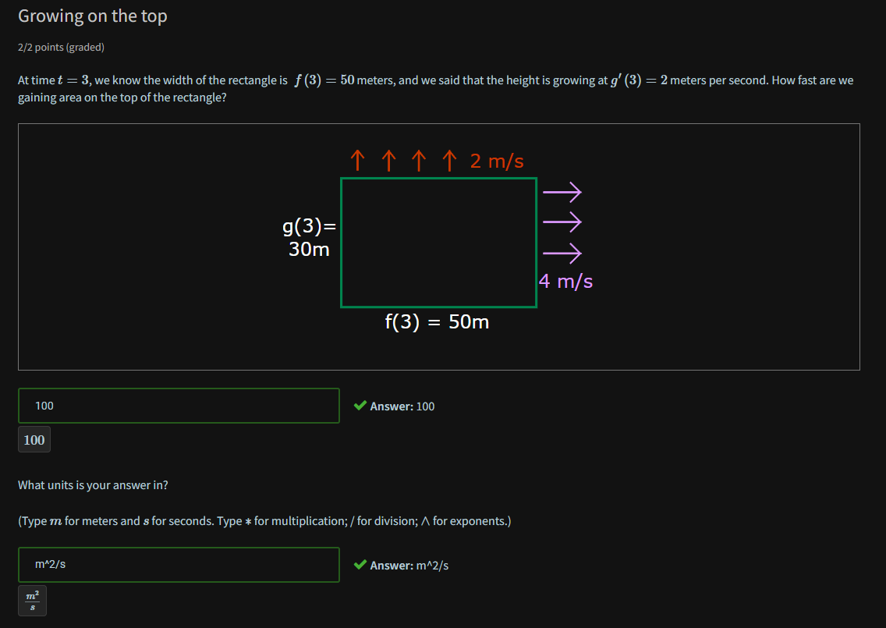

The width is 50 meters, and the top of the rectangle is moving up at 2 meters per second, so, on the top, we are gaining area at a rate of 50m×2 m/s , or 100m^2/s . The units work out perfectly!

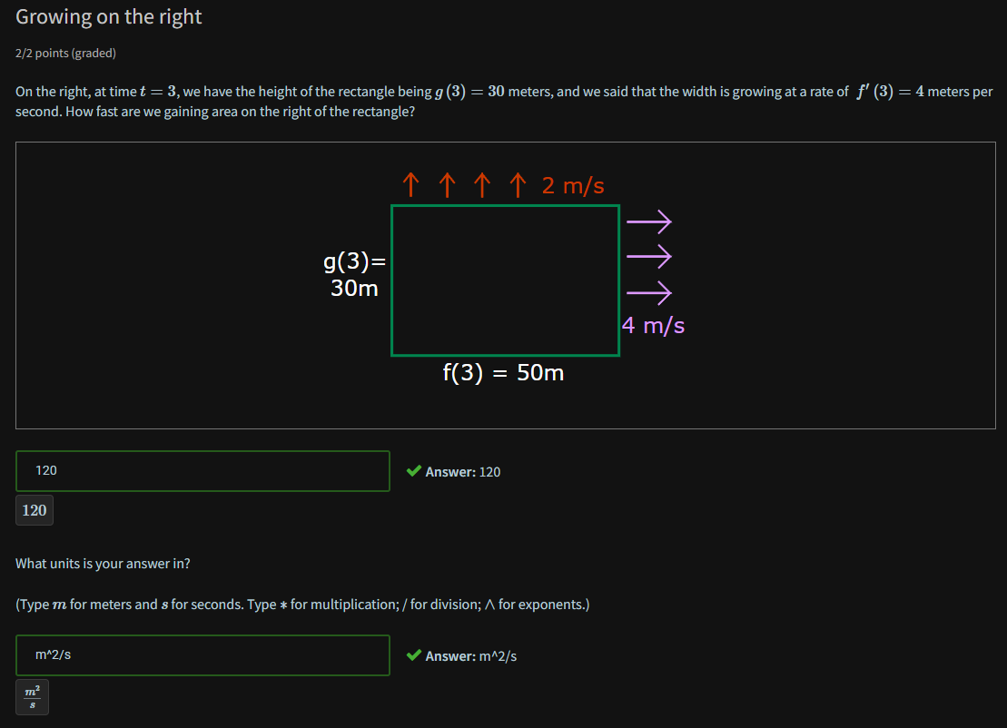

30 meters times 4 meters per second is 120 square meters per second.

